
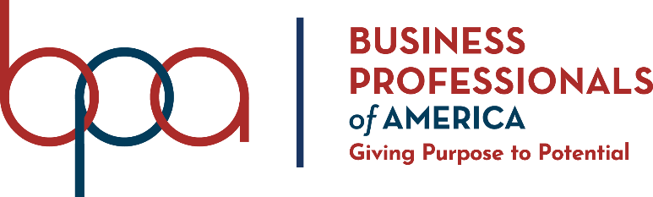
GRAPHIC DESIGN PROMOTION
(410)

NATIONAL 2020

Judges: Please double check and verify all
scores and answer keys!

Property of Business Professionals of America.
May be reproduced only for use in the Business Professionals of America
Workplace Skills Assessment Program competition.

Description
Develop a theme, illustrate the theme in a logo design, and then utilize the logo in a promotional flyer.

The output of this competition is to be produced as the basis for NLC theme and advertising for 2021.

Topic
Develop a logo, tagline, and flyer promoting the Business Professionals of America National Leadership Conference in Orlando, FL, May 5-9, 2021.

judging procedure
- Contestants will be introduced by contestant number. Contestants may continue to wear their name badges.
- As a team of judges, formulate two (2) to three (3) questions to ask at the conclusion of the presentation. Be sure to ask the same questions of each contestant.
- Contestants will present before a panel of judges and timekeeper.
- Set-up time will be no longer than three (3) minutes.
- The length of the presentation will be no more than six (6) minutes; followed by judges’ questions not to exceed five (5) minutes.
- The presentation will be stopped at six (6) minutes.
- Excuse contestants upon completion of judges’ questions.
- There can be no ties in the top ten (10) contestants. It is the responsibility of the judges to break any ties.
- Administrator will fill out ranking sheet prior to dismissing the judges.
- If more than one (1) section is necessary, finalists will be determined by selecting an equal number from each section.
- Give administrator all Judges’ Scoring Rubrics, Judge Comment Sheets and contest materials.
- No audience is allowed in the contest room.

Please double-check and verify all scores!

